# Windows Container Demo for Azure Service Fabric

**Prerequisites for development machine**

**(Note: No need to perform these prerequisites steps for lab machines, please proceed for the lab)**

1. Get a physical machine or Azure VM with "Windows Server 2016 with containers" for your development machine.
2. Install [Nodejs tools for Visual Studio](https://www.visualstudio.com/vs/node-js/)
3. Install [Nodejs 6.9.1 x64 runtime](https://nodejs.org/en/) (Note: You can choose other nodejs runtime versions, but you will need to change the dockerfile accordingly in the BackendService project)
4. Install the Service Fabric SDK (version 5.4.x and above)
5. Azure CLI 2.0

**Lab**

* Click on the CTRL+ALT+DELETE button present on right hand side panel.
* Login to the Lab machines with user – msready2017, password – Msready2017lab.
* Open the Windows Lab manual present on Desktop. This will help you in copying and pasting the commands, instead of typing them (Make sure you use the **Windows** User manual and not Linux one).
* Open the browser and browse to <http://aka.ms/tryservicefabric>.
* If you get the security warning, click on Add -> Add and close.

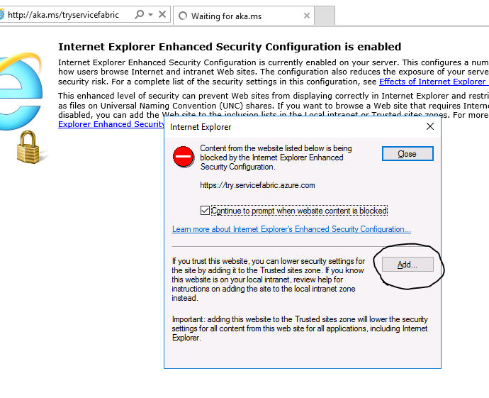

* Login with Github or Facebook account and Join the Windows cluster.

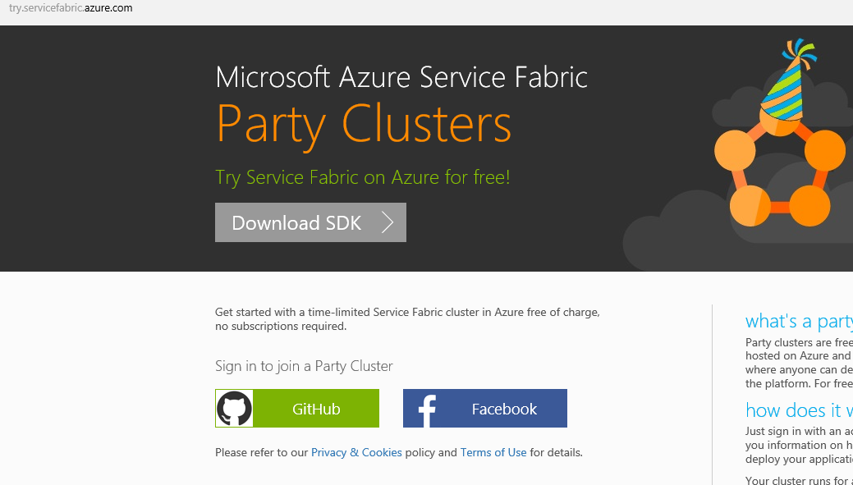

* Open the Service Fabric Explorer by clicking on the link provided. You might be prompted for the security warning again. Please use same Add method mentioned above.

**Exercise 1: Deploy the container application**

In this exercise, we will deploy the container application to the service fabric cluster.

* Open the command prompt. Connect to the cluster, using the Azure cli –

*sfctl cluster select --endpoint http://<Cluster FQDN>:19080*

* Copy the package, register it and create application –

*cd C:/ServiceFabric*

*sfctl application upload --path sf_containers1*

*sfctl application provision --application-type-build-path sf_containers1*

*sfctl application create --app-name fabric:/Container.Application --app-type Container.ApplicationType --app-version 1.0.0*

Note the version number is 1.0.0 here.

You would observe that the services show “In Build” status for some time.

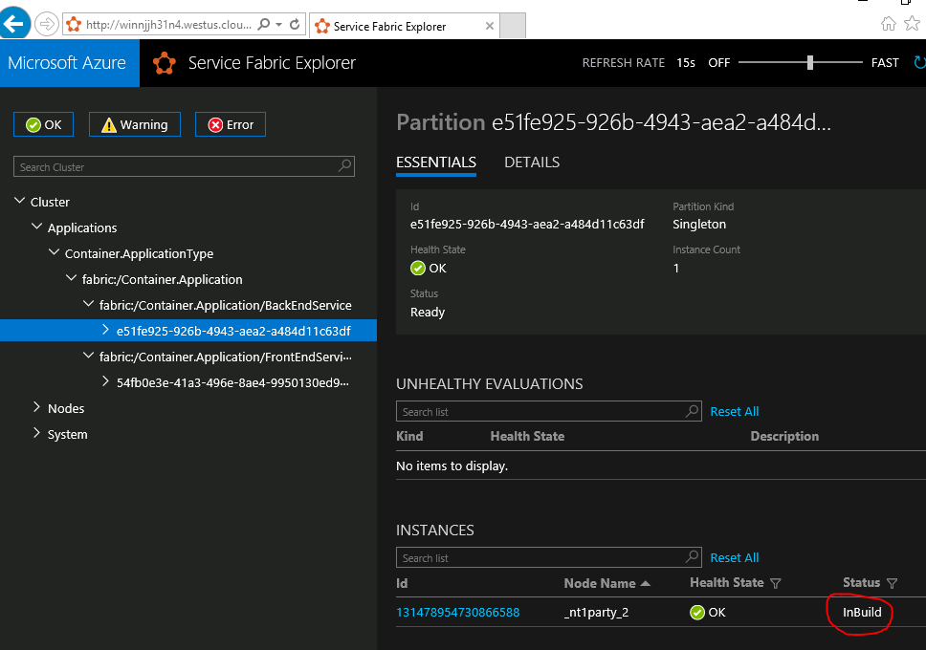

Instead of waiting on those containers to download and stabilize, you can start up local cluster and deploy containers with **Exercise 5 – Debugging Lab**.

By now the containers should have been downloaded and stabilized, so browse to http://<Cluster FQDN>:20003 to check if it is working.

**Exercise 2: Scaling the application**

In this exercise, we will learn how to scale number of instances for your application.

* Scale up the number of instances of the Backend service using the Service Fabric Explorer. Browse to SFX at http://<Cluster FQDN>:19080.

Click on the service within the application. On the right-hand side, you should see the “Actions” button. Click on Actions button and select “Scale service”. Change the number to 3 instances. Observe the number of instances in SFX.

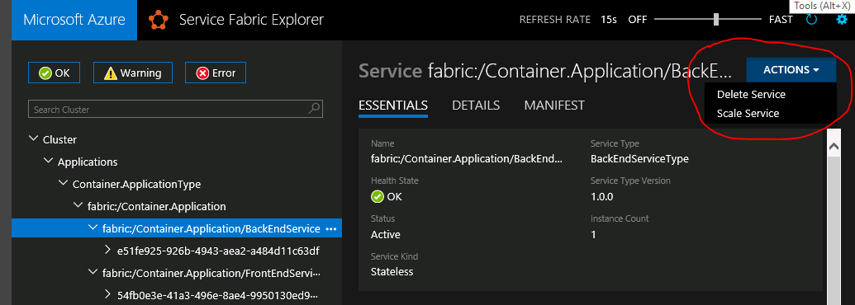

* Test by opening the IE in in-private mode and observing that the backend node showed are different with refresh.
* Using same method above scale down the number of instances to 2.

**Exercise 3: Failover to another node**

In this exercise, we will learn how to failover of node works in case node is down.

* Browse to service fabric explorer.
* Expand the nodes tree on left side.
* Click on the “…” for one of the node where your backend service is running.
* Select restart

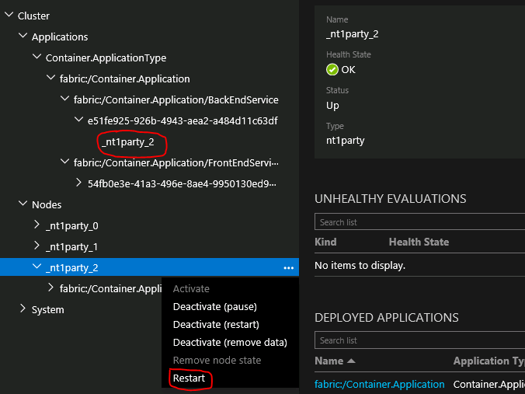

* Observe how the backend service fails over from one node to another while the application is still up and running in the browser.

**Exercise 4: Rolling upgrade for the application**

Make sure to change the version type in folder.

In this exercise, we will learn how to upgrade your application to newer version.

* Deploy the version 2 application by copying the package in Imagestore –

*sfctl application upload --path sf_containers2*

*sfctl application provision --application-type-build-path sf_containers2*

* Start Upgrade

*sfctl application upgrade --app-id fabric:/Container.Application --app-version 2.0.0 --parameters “{}” --mode Monitored*

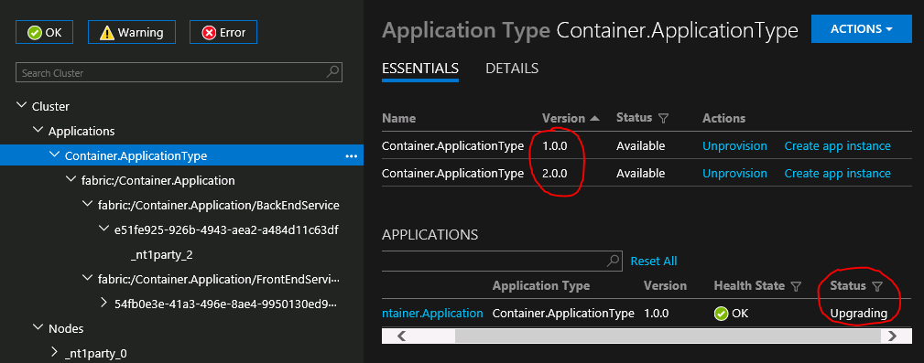

Check the Application on the browser, you should see the upgrade progress from 1.0.0 to 2.0.0.

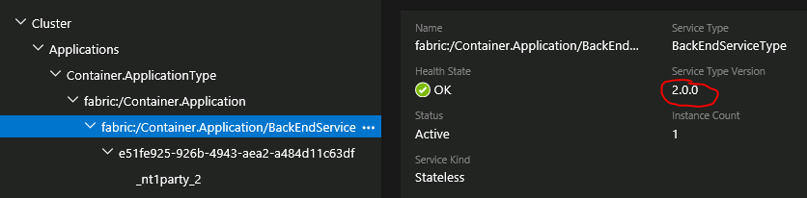

Once upgrade is complete browse to http://<Cluster FQDN>:20003.

**(Only Local cluster) Exercise 5: Debugging Lab**

1. To deploy locally first start the local cluster using the Service Fabric cluster manager – Right click on the SF cluster manager icon in the right tray and choose “Start Local Cluster”.

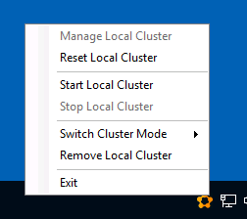

* Open the command prompt. Connect to the cluster, using the Azure cli –

*sfctl cluster select --endpoint http://localhost:19080*

* Copy the package, register it and create application –

*cd C:/ServiceFabric*

*sfctl application upload --path sf_containers1*

*sfctl application provision --application-type-build-path sf_containers1*

*sfctl application create --app-name fabric:/Container.Application --app-type Container.ApplicationType --app-version 1.0.0*

1. To debug docker logs get the CONTAINER ID with

*docker ps -a*

Then get logs for the container instance

*docker logs [CONTAINER ID]*

Note: If you are jumping to this exercise from exercise 1, **make sure to connect your party cluster again using the 1st command of exercise 1** once the deployment is over.

**Exercise 6: Additional Information**

This is an observation exercise only. Please browse to SFX and click on the cluster. Open the Manifest tab for your cluster. Check the details of the Nodes and Ports open on each node. Similarly observe the Manifest files for your Applications and Services.